# Plan’s History

Invarion Cloud keeps track of every modification made to the plan. Anytime the plan autosaves a new recovery point is made. Thanks to this you can easily go back to any previous version of the plan undoing some unwanted changes made by yourself or other collaborators. It is like turning back the clock.

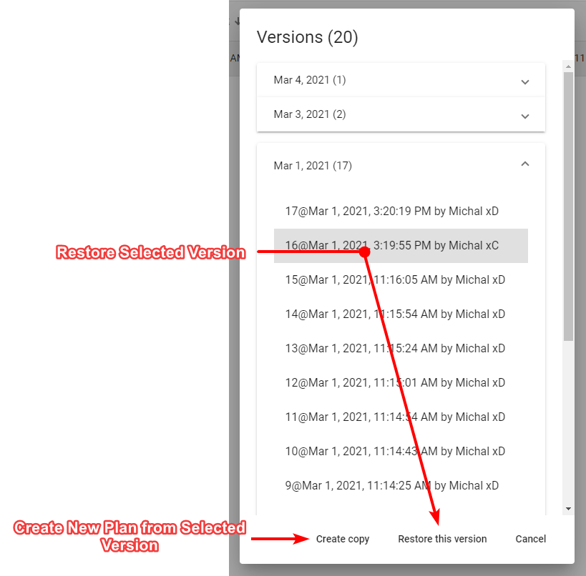

Plan’s History

To use recovery options select “History” from the plan’s context menu. A new dialogue will appear listing all the possible recovery points for this plan. Select the one you are interested in and choose one of two options, “Restore this version” or “Create copy”. The former restores the original plan to the selected previous version. The latter creates a new plan from information saved in the selected recovery point. Recovery points listed in the “History” dialogue are divided by date. Additionally to that each one has unique number, timestamp and user responsible for the modification made to the plan.

**Note:** If you restore a previous version of the plan, you will still have access to the later versions of the document. So, no risk is involved.

**Tip:** Plan’s history may also come in handy when something unexpected happens to your plan. You can then retrieve last correctly working version of the plan.